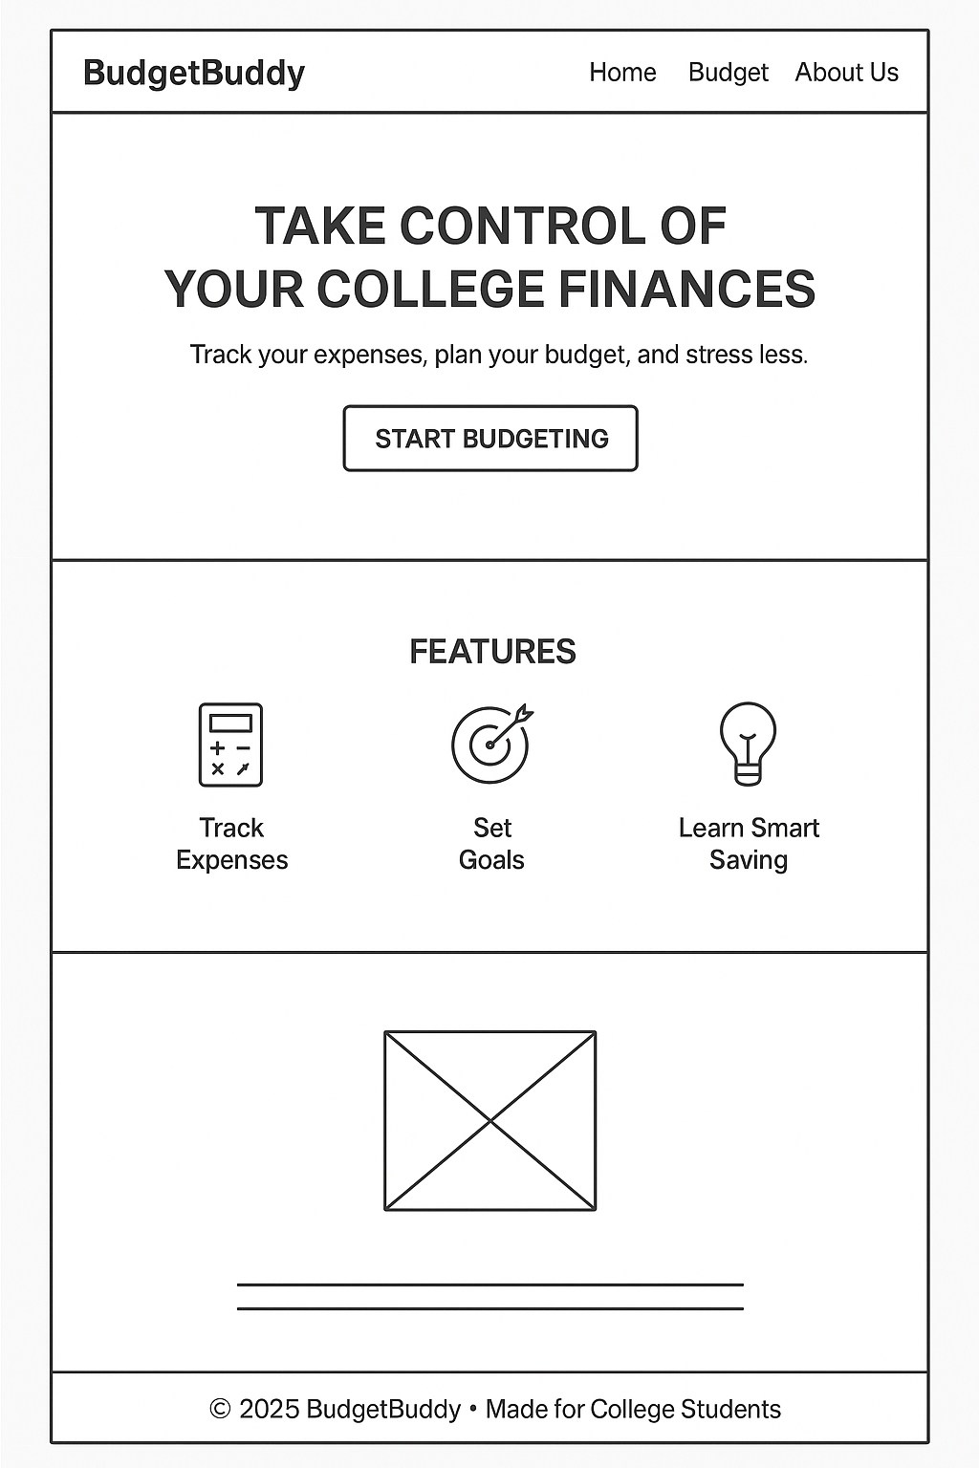

Image on Bottom: Logo Image

Two lines under: The Elevator Pitch (Page 5)

[START BUDGETING] - Takes you to next page

The “HOME” “BUDGET” and “ABOUT US” on the top should link you to those respective pages.

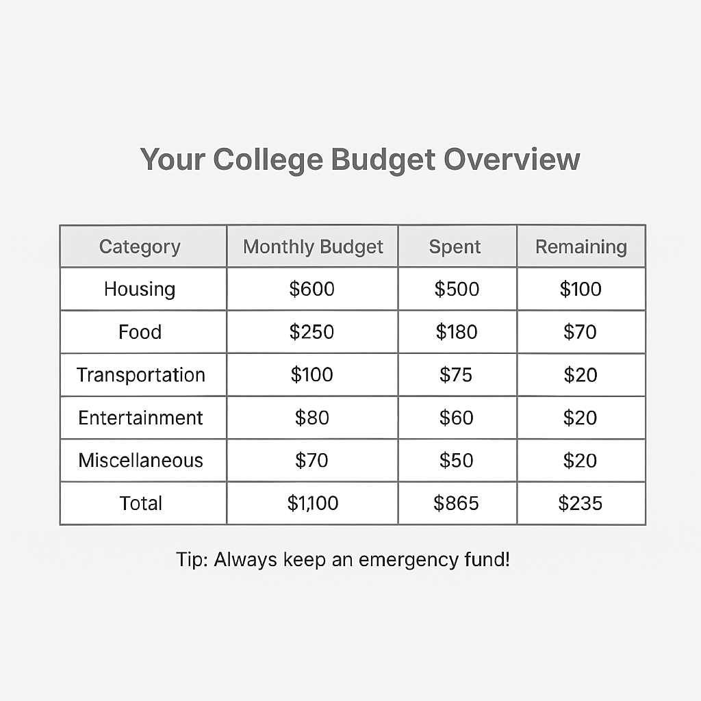

Make it a pre-set budget sheet, sort of like the one presented above. If desired, add a background image behind (Just find like, a Walmart line or something).

Also do me a favor and add the “HOME” “BUDGET” and “ABOUT ME” quick links to the top. I don’t know how I forgot to do that.

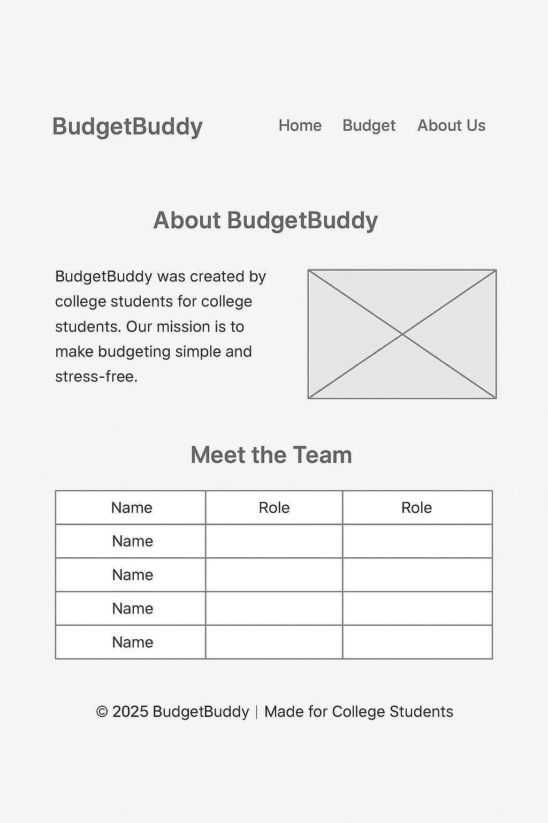

Insert the names of everyone who works on the sheet.

First slot: Gavin Schofield | Client / Designer

Second Slot: [NAME] | Home Page

Third Slot: [NAME] | Budget Page

Fourth Slot: [NAME] | About Us Page

Colors: [Primary: #2e7d32] [Secondary: #a5d6a7] [Background: #ffffff] [Text Color: #333333] [Borders/Table Line: #bdbdbd] [Additional Shading (if needed): #e8f5e9]

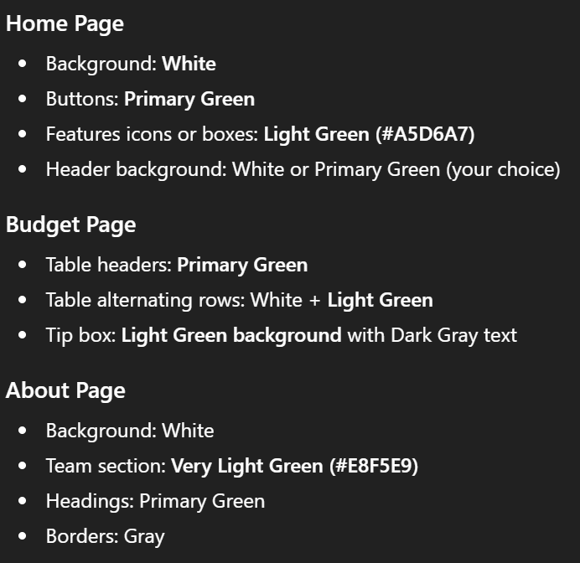

Logo down below



(Font Choices Below)



(Elevator Pitch Below)

**BudgetBuddy helps college students keep track of their money without stress. It shows where your cash is going, helps you stay on budget, and teaches smart saving habits so you can focus more on school and less on financial stress.**